FOI 5725

**9. How much is the total ~~stamp~~ / franking costs of letters sent via post**

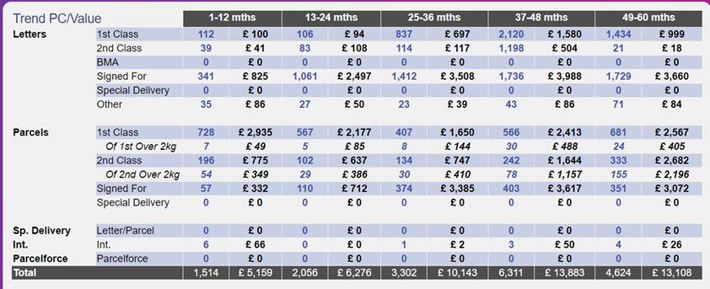

**10. How much is spent on post in total**

|  |  |
| --- | --- |
| Financial Year | Amount (£) |
| 2019 | £221,737.49 |
| 2020 | £242,513.94 |
| 2021 | £220,862.94 |
| 2022 | £393,843.37 |
| 2023 | £231,057.17 |